Placa de distribuição
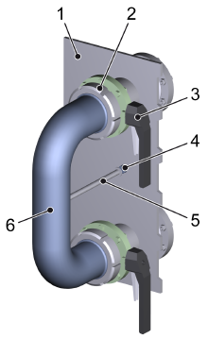
Figura Erro! Nenhum texto com o estilo especificado foi encontrado no documento.-1: Detalhes da placa de distribuição
Nº | Descrição | Nº | Descrição
1 | Distributor plate | 2 | Milk pipe joint
3 | Manual shut-off valve | 4 | Proximity switch
5 | Initiator rod | 6 | Distributor swing bend

Mounting the distributor swing bend
Público Alvo: | - Operadores
- Check the seals at the end of the distributor swing bend.
- If the seals are faulty or incorrectly positioned, notify maintenance personnel and replace the faulty or defective seal immediately.
- Close all manual shut-off valves on the distributor.

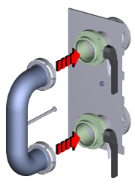
Figura Erro! Nenhum texto com o estilo especificado foi encontrado no documento.-2: Positioning the distributor swing bend
- Position the distributor swing bend on the connections to be made.
 | AVISO!  Improper tightening of milk pipe joints  Improper tightening of milk pipe joints can result in damage to seals.  This may result in damage to the machine and loss of media.  - Check seals are positioned correctly  - Check seals for leaks  - Install milk pipe joints by hand  - Tighten milk pipe joints by hand with the adjustable hook wrench supplied  - Do not make any changes to the adjustable hook wrench  - Tighten with normal exertion of force

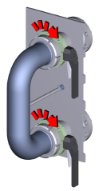
Figura Erro! Nenhum texto com o estilo especificado foi encontrado no documento.-3: Attaching the distributor swing bend securely
- Attach the distributor swing bend securely to both connections.
- Open both adjoining manual shut-off valves.

Removing the distributor swing bend
Público Alvo: | - Operadores
 | AVISO!  Escaping media  Remnants will flow out of the swing bends when they are removed. There is a danger of injury from contact with corrosive substances and irritants. There is an additional danger of skin burns from hot media. Risk of slipping on walkways.  This could cause severe and even fatal injury.  - Guard against burns by always wearing protective gloves.  - Wear protective clothing adapted to the media that provide protection against corrosive substances, irritants, and skin burns.  - Wear safety shoes with non-skid soles.  - Dry wet surfaces immediately.  - After sanitizing, flush off and dry all surfaces exposed to media thoroughly with water.
- Close the feed manual shut-off valve.
- Close the outfeed manual shut-off valve.

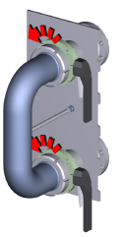
Figura Erro! Nenhum texto com o estilo especificado foi encontrado no documento.-4: Unscrewing the distributor swing bend
- Loosen the milk pipe joints of the distributor swing bend at both connections.
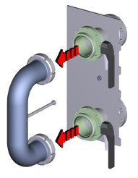
Figura Erro! Nenhum texto com o estilo especificado foi encontrado no documento.-5: Removing the distributor swing bend
- Carefully remove the distributor swing bend.

Distributor in the media feed
To achieve different media passages for the production process or the cleaning process, the media passages must be set on the distributor.
The media passages are dependent on the program selected or the program options.
The program prompts the operator to set the required media passage.
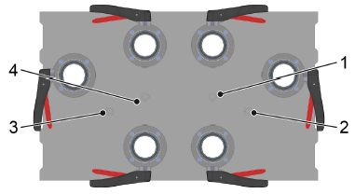
Figura Erro! Nenhum texto com o estilo especificado foi encontrado no documento.-6: Visão geral dos sensores
Nº | Descrição | Nº | Descrição
1 | CR70-BG81 | 2 | CR70-BG80
3 | CR70-BG83 | 4 | CR70-BG82

Swing bend position for different media passages
Esquema de limpeza | Sensores ocupado | Swing bend position
Xaroparia | CR70-BG80  CR70-BG82 | 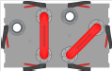
Envasadora / blender | CR70-BG81  CR70-BG83 | 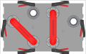

Setting the media passages
Público Alvo: | - Operadores
Prerequisite: The program requests that the swing bend position is changed.
- For details of the media passages to be set: see the table for the swing bend position on the distributor.
- Close all manual shut-off valves on the distributor.
AVISO!
Escaping media
Remnants will flow out of the swing bends when they are removed. There is a danger of injury from contact with corrosive substances and irritants. There is an additional danger of skin burns from hot media. Risk of slipping on walkways.
This could cause severe and even fatal injury.
- Guard against burns by always wearing protective gloves.
- Wear protective clothing adapted to the media that provide protection against corrosive substances, irritants, and skin burns.
- Wear safety shoes with non-skid soles.
- Dry wet surfaces immediately.
- After sanitizing, flush off and dry all surfaces exposed to media thoroughly with water.

- Install the swing bends on the distributor in accordance with the selected media passages.
See section “Distributor”.
- Open the manual shut-off valves that are connected by swing bends.

